James Keller – GES408 – Week 7 Lab – Invertebrate Abundance
Report the mean and standard deviation of total invertebrate count for each microhabitat (1 point).
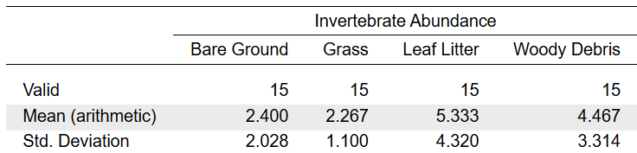
Display a boxplot of the data. Which microhabitat appears to have the highest median abundance? Which appears to have the most variability (or the widest spread)? (2 points)
The microhabitat with the highest median abundance is a tie between Leaf Litter and Woody Debris at 4. The microhabitat with the widest spread of data is Leaf litter.
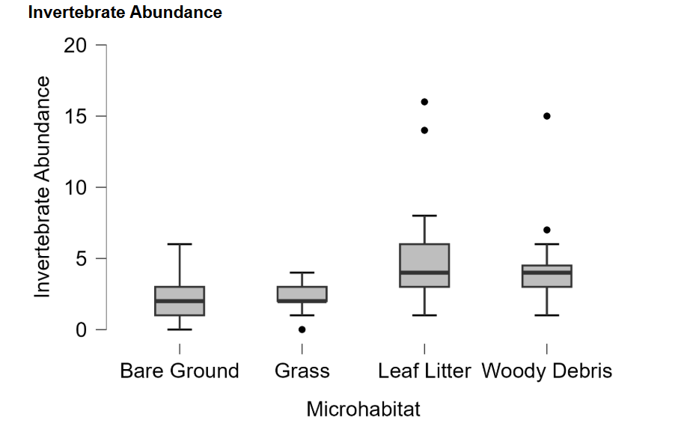

Is the assumption of homogeneity of variance met? Explain. (2 points)
The assumption of homogeneity of variance is not met because our p-value for Levene’s test is significant at 0.24
Based on the Q-Q plot (and given that we have count data and will see "steps" on the plot), do the residuals look approximately normally distributed? If not, what shape of departure do you see (e.g., upward curve on right side/right-skew, etc.)? (1 point)
Our data does not seem to be normally distributed because the dots on our Q-Q plot do not fall on the line and there seems to be a curve on both ends.
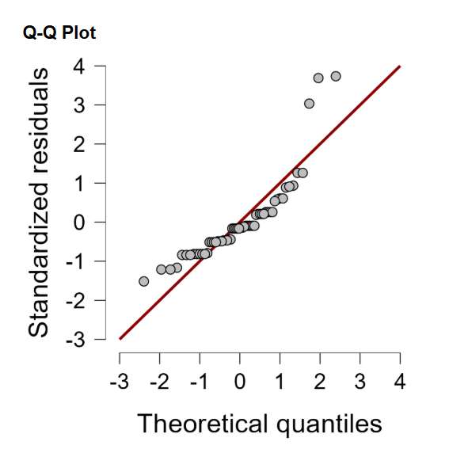
Count data like this is a known case where ANOVA assumptions are often violated. If you feel it necessary, you can perform a square root transformation on the invertebrate abundance data by computing a column with this R code: sqrt(Invertebrate Abundance+1)
All of my statistics past this point are computed using the square root transformed data.

Report the F-statistic and the p-value of your ANOVA. Do you reject the null hypothesis? State the null as a part of your answer. (2 points)
The F-statistic of the square root transformed data is 4.825 and the p-value is 0.005. Based on this, we can reject our null hypothesis that all groups have a statistically similar average.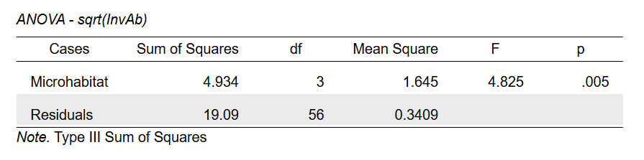
If your ANOVA was significant, display a Tukey HSD post-hoc test. Which specific pairs of microhabitats differ significantly from each other (p < 0.05), and which do not? (If your ANOVA was not significant, please restate that here.) (1 point)
The specific pairs that are significant are: Bare Ground – Leaf Litter & Grass – Leaf Litter.
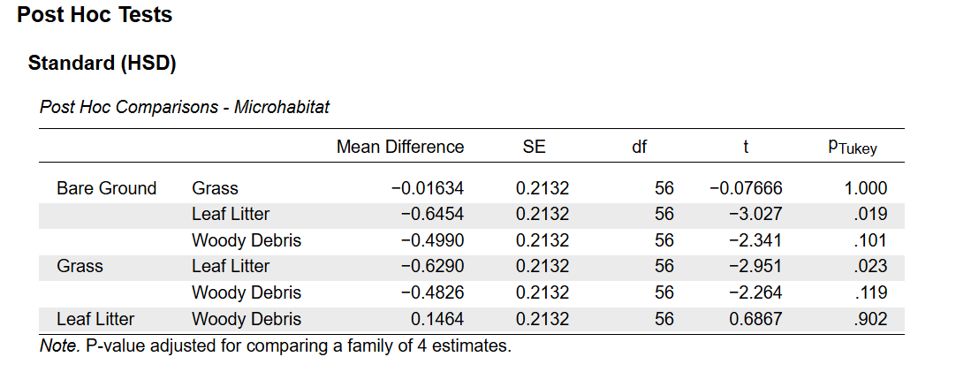
What is the experimental unit in this study? Briefly explain. (1 point)
The experimental unit in this study would be 1 quadrat.
Propose at least one ecological explanation for the pattern you found (or didn't find) across microhabitats. (2-3 sentences) (1 point)
One ecological explanation that could explain the pattern we found is that habitat with more “complexity” can serve as better habitat for invertebrates. This would make sense seeing that our habitats proceed in order of complexity: Bare Ground -> Grass -> Leaf Litter and our significant groups were between leaf litter and bare ground / grass. Woody debris may not be significant because debris in different states of decay would be of different quality habitat to invertebrates.
For most of our microhabitats, we used a fixed time (2.5 minute search) + fixed area (quadrat) approach to sampling for invertebrates. What abstract concept do these kinds of things help control for, and why might ecologists want to specify these when conducting a repeatable study? (2-3 sentences) (1 point)
These help to control sampling effort between quadrats. We want to ensure differences in invertebrate abundance are due to actual differences in microhabitat and not the effort put into sampling.
What is at least one source of bias/confounding in this design that could produce a false microhabitat effect (even if our ANOVA was not significant/invertebrates don't actually prefer one habitat over another)? (Think about space, time, etc.) (2-3 sentences) (1 point)
One source of bias for this experiment is observer bias, we switched out who was observing each microhabitat so if one person is better at spotting tiny invertebrates than another, they could find more. Another confounding variable could be the canopy cover over each site. In the grassy areas it could be easier for birds to spot invertebrates than in the leaf litter which has very high canopy cover.

